Centenary Secondary School

June Examination – 2012

Information Technology - Paper 2

Grade 10 Time: 2 hrs Marks: 100

**INSTRUCTIONS:**

1. This paper consists of **6** pages of print (incl this one) and **5** questions
2. Answer ALL questions
3. It is in your own interest to write neatly and legibly
4. Number your questions exactly as the questions are numbered

**SECTION A**

**QUESTION ONE**

**1.1 Match the description in column A with the correct term from column B.  
Write down the number 1.1.1 to 1.1.10 and the letter of the correct term.**

|  |  |  |  |
| --- | --- | --- | --- |
| **COLUMN A** | | **COLUMN B** | |
| 1.1.1 | Files and parts of files are scattered on the hard disk. | A. | Drivers |
| 1.1.2 | Devices that are connected to the PC are automatically  detected and configured for use. | B. | Administrator  Account |
| 1.1.3 | Software that enables the operating system to communicate with hardware devices. | C.  D. | Product Code  Defragmentation |
| 1.1.4 | Allows you to view and print the contents of PDF documents directly from within your browser. | E.  F. | Limited User Account  Firewall |
| 1.1.5 | A widely used utility program to compress files. | G. | PDF |
| 1.1.6 | A special account which allows the user to make any changes they wish to the system. | H. | Adobe reader |
| 1.1.7 | Uses visual controls to allow the user to interact with the computer or with programs on the computer. | I. | fragmentation |
| 1.1.8 | Part of systems software and performs maintenance and administrative tasks. | J. | WinZip |
| 1.1.9 | A popular format to distribute documents electronically. | K. | Plug and Play |
| 1.1.10 | Reduces illegal installation of software | L. | GUI |
|  |  | M. | Utilities |

**1.2 State whether the following statements are true or false:**

1.2.1 Disk clean-up is a utility program that removes temporary files created by windows.

1.2.2 A program is a physical component of a computer that can be used.

1.2.3 Most modern cell-phones can connect to the internet.

1.2.4 Proprietary software allows you to access and modify the code.

1.2.5 Hardware refers to the set of instructions that tells the computer what to do.

1.2.6 Shareware programs are free and can be used for as long as you want.

1.2.7 When data is processed into something meaningful it is called information.

1.2.8 An anti-virus program is an example of systems software

1.2.9 Optical disks (e.g. CD’s) are faster than hard disks.

1.2.10 Peripheral devices refer to equipment used by the computer to get input  
and to provide output.

**Total = 20**

**SECTION B**

**Scenario**

*Your dad has decided to start his own business. Recently he made contact with a company that can supply him with men’s clothing directly from the factory at factory prices. He opened a small business where he buys and sells clothes to the public and other retailers in your area. Business has been doing well and he now wants to buy a computer to assist him in record keeping, invoicing, internet banking etc.*

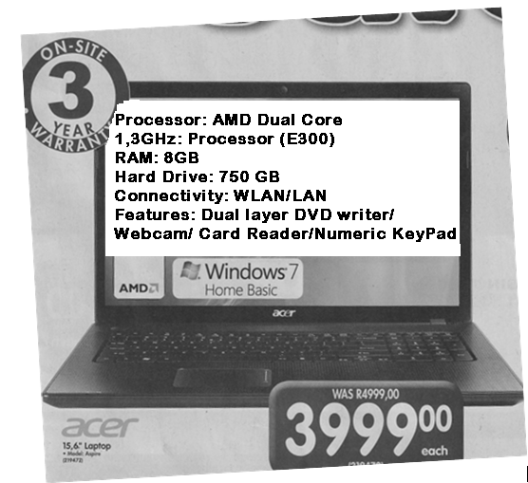

**QUESTION TWO**

2.1 *Your dad went to a computer store to view the laptop shown in the advert above. He explains that laptops are good but the salesman said the only snag is that they are expensive to repair and almost impossible to upgrade.*

2.1.1List two advantages of a portable computer as compared to a desktop   
computer (2)

2.1.2 The salesman said that the desktop PC is more modular in design and hence   
easier to repair and upgrade. Explain the term modular design. (2)

2.1.3 Which company makes the processor in the advert? (1)

2.1.4 Write down the name of another famous company that makes processors for  
laptops. (1)

2.1.5 a) What does the acronym RAM stand for? (1)

b) Briefly explain what RAM is used for? (2)

2.1.6 Briefly explain to your dad what the following items do:

a) Hard drive (2)

b) Dual-layer DVD Writer (2)

c) Webcam (2)

d) Card reader (2)

e) Numeric keypad (2)

2.2 The salesman said that the 8GB flash disks are on special. Briefly explain what  
a flash drive is and what it is used for.? (2)

2.3 Your dad needs to purchase a printer. Briefly explain to him the advantages  
of buying a colour ink-jet printer for his business. (2)

2.4 Instead of showing prospective groups of buyers at meetings actual samples of   
clothes, you suggest that he make power-point presentations. What device will  
he need so that he can display his presentations to clients at these meetings? (2)

2.5 For business to be successful your dad will have to go to clothes displays and fashion shows. He will be working with a large number of photographs taken on his digital camera. This laptop is equipped with 2 ports and a card reader that could be used to transfer pictures from the camera to the laptop.

Write down the names given to these two ports and briefly explain what each one is used for. (4)

2.6 Your dad owns a cell phone that has Bluetooth capabilities. Upon checking with  
the salesman he confirms that this laptop also has Bluetooth. Briefly explain how  
he could go about transferring data between the two devices via Bluetooth. (2)

**Total = 30**

**QUESTION THREE**

*This computer comes with Windows 7 Basic. The salesman tells your dad he can purchase  
Windows 7 Ultimate or change to an Open-source operating system. At this stage your dad  
comments that this is beyond him and he needs to consult with you before he decides what  
to do.*

3.1.1 What is an operating system? (2)

3.1.2 What is the purpose of an operating system? (2)

3.1.3 {**Windows 7, UNIX, Windows mobile, Linux, Windows Server 2008**}

*The operating systems listed above can be classified according to the types of  
 computers they are used in. From the given list give an example of an operating*

*system that can be classified as:*

1. A network operating system
2. An embedded operating system
3. A stand-alone operating system (3)

3.2.1 What are utility programs and what are they used for? (2)

3.2.2 What utility program will you require to:

a) Prevent your PC from being infected with a virus.

b) Reduce the size of a file so that it takes up less space to store.

c) Make a back-up of files on your hard disk. (3)

3.3 How does application software differ from systems software? (2)

3.4 What are the disadvantages of using open source software? (2)

**Total = 17**

**QUESTION FOUR**

Start

S

M < 6

TOT 🡨 0

M 🡨 1

F

T

num

T

TOT

num< 0

F

Stop

num🡨 0

TOT 🡨 TOT + NUM

M 🡨 M + 1

4.1.1 How many decision boxes/symbols are there in the above flowchart? (1)

4.1.2 Which variable in the flowchart is the counter? (1)

4.1.3 Trace the flowchart using the following input list:

5; -4; 0; 7; -2; 8 (4)

4.1.4What is the flowchart doing? (2)

4.1.5 What outcome would altering box 4 have if box 4 was changed to read:

num> 0

(2)

**4.2 Study the given scratch program.**

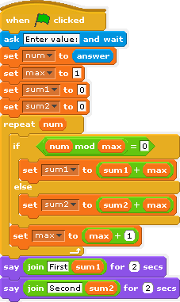

4.2.1 Determine the output if the number 12 was provided as input. (6)

4.2.2 What is the program doing? (2)

4.3 Write an algorithm that will accept as input an integer value (n). Your algorithm must  
 then determine and output the answer to n! where n! = n x (n-1) x (n-2) x … 1

Example for n=5 the required output will be determined as follows:

5 x 4 x 3 x 2 x 1 = 120 (5)

**Total = 23**

**QUESTION FIVE**

5.1 Convert the following numbers from base 10 to the indicated base (show all working)

5.1.1 127 to base 2

5.1.2 456 to base 16 (5)

5.2 Convert the following from the indicated base to base 10 (show all working)

5.2.1 10110112

5.2.2 43A2116 (5)

**Total = 10**

**GRAND TOTAL = 100**